AWS Face Recognition project

**By**

**PEDDISETTI REVANTH SAI**

**Screenshots needed for dashboards:**

**1.AWS login screen with username**

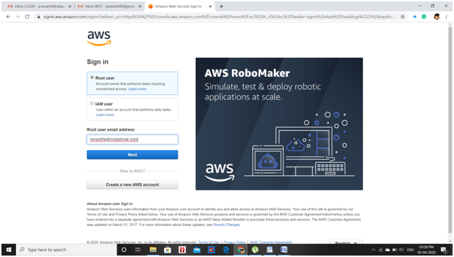

**2.EC2 Dashboard**

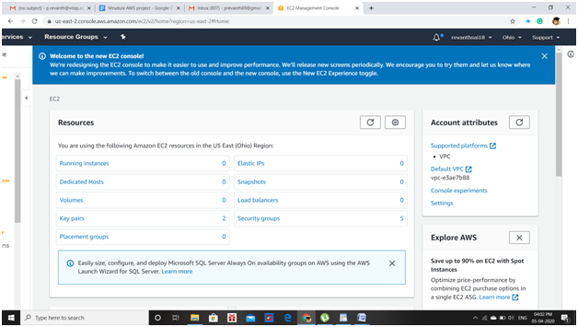

**3.S3 Dashboard**

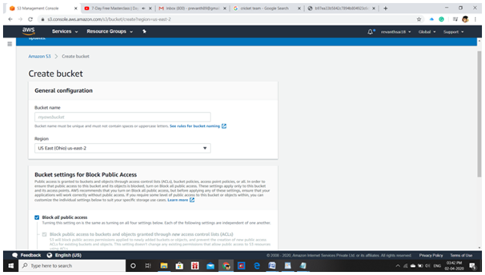

**4.Rekognition Dashboard**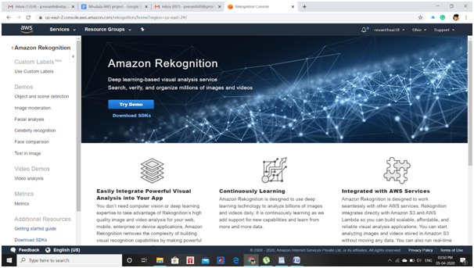

**Screenshots needed for EC2:**

**1.Choosing an AMI**

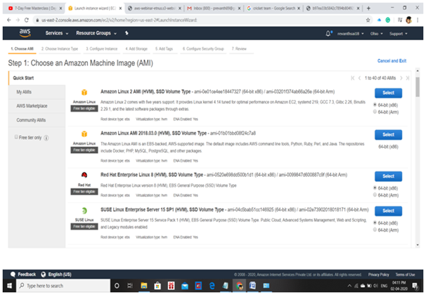

**2.Choosing an Instance type:**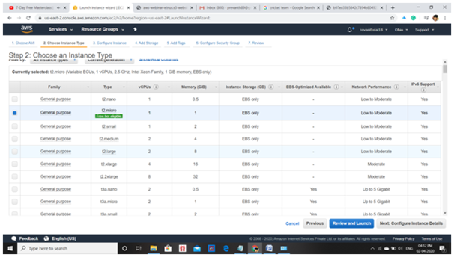

**3.Adding storage:**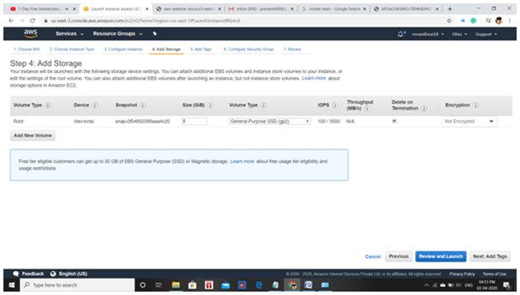

**4.Configuring security group:**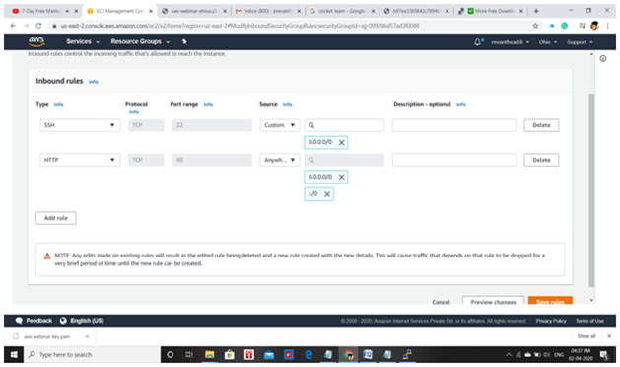

**5.Keypair download**

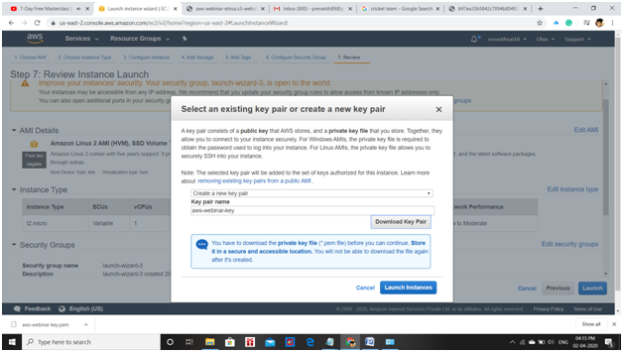

**6.Puttygen conversion from pem to ppk:**

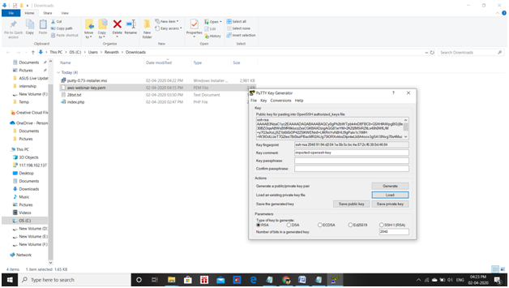

**7.Logged in EC2 black screen:**

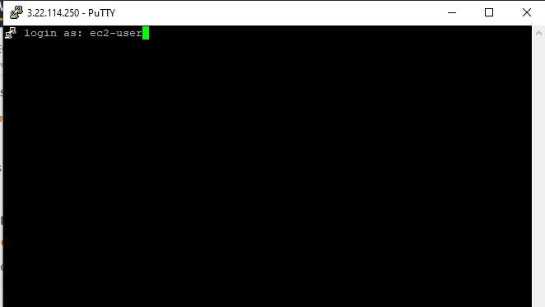

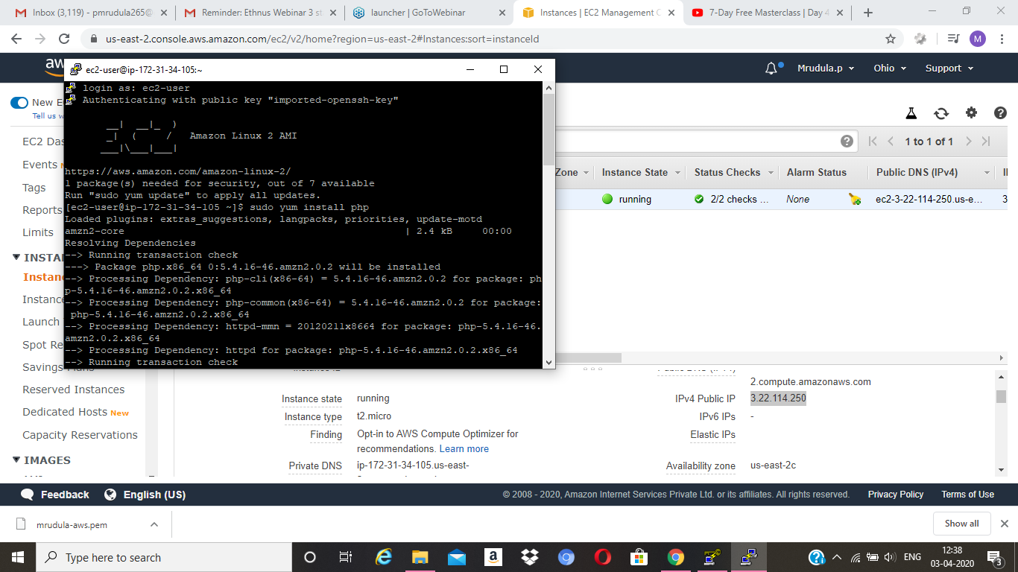

**Screenshots needed for S3:**

**1.Creating a bucket:**

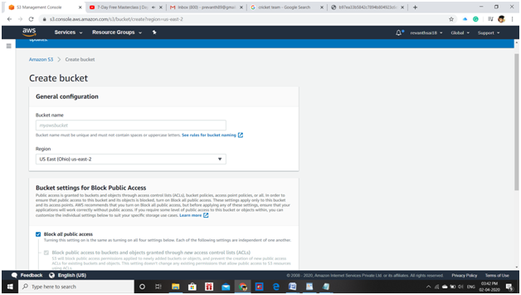

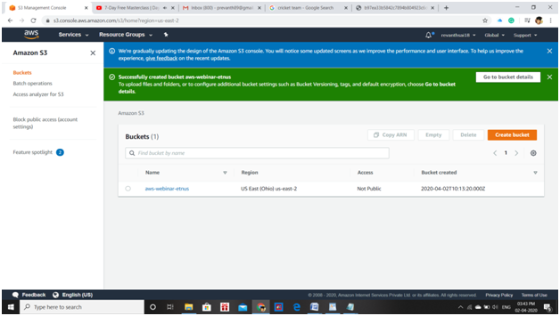

**2.Uploading an object:**

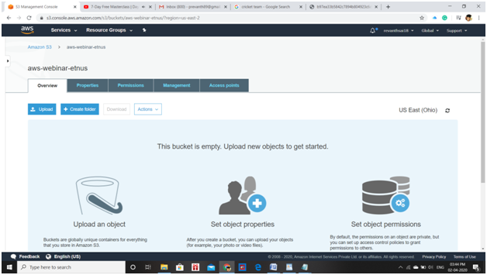

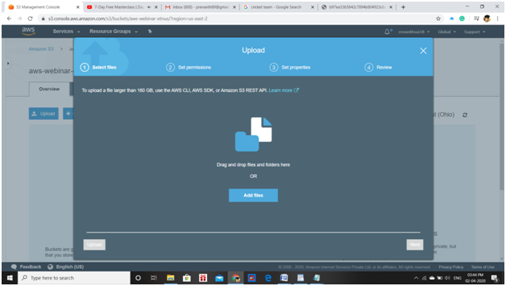

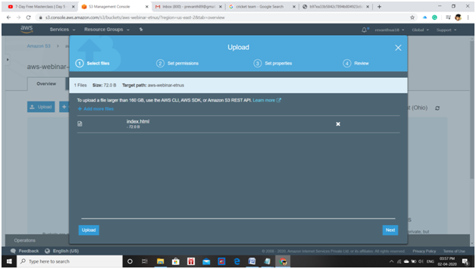

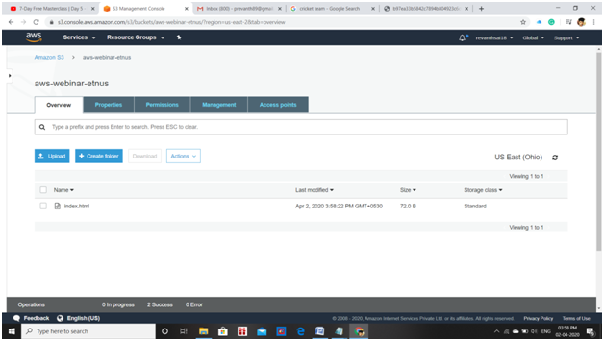

**3.Enabling static website:**

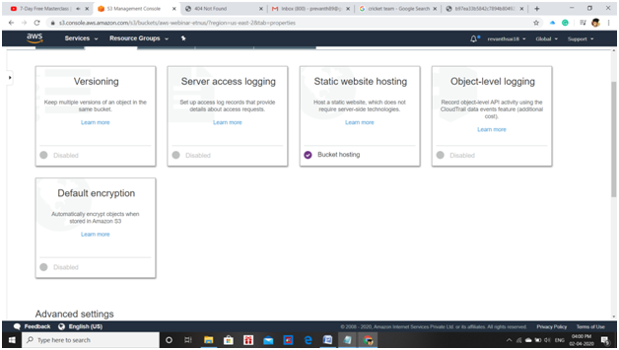

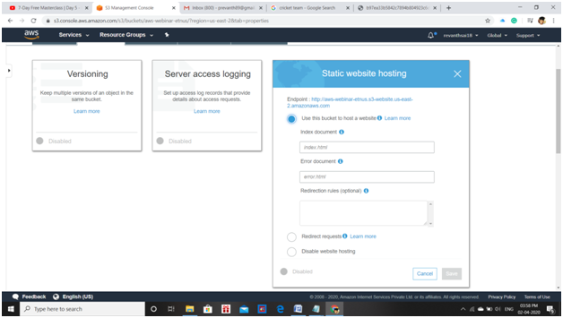

**4.Making the object public:**

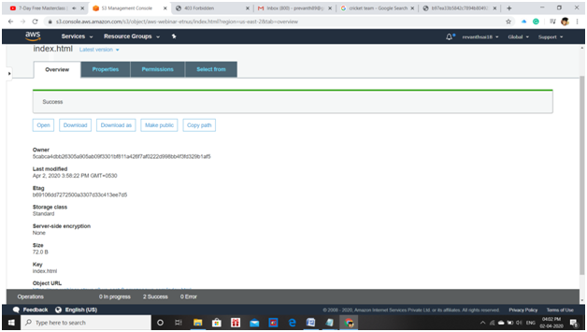

**5.Checking the S3 link in browser:**

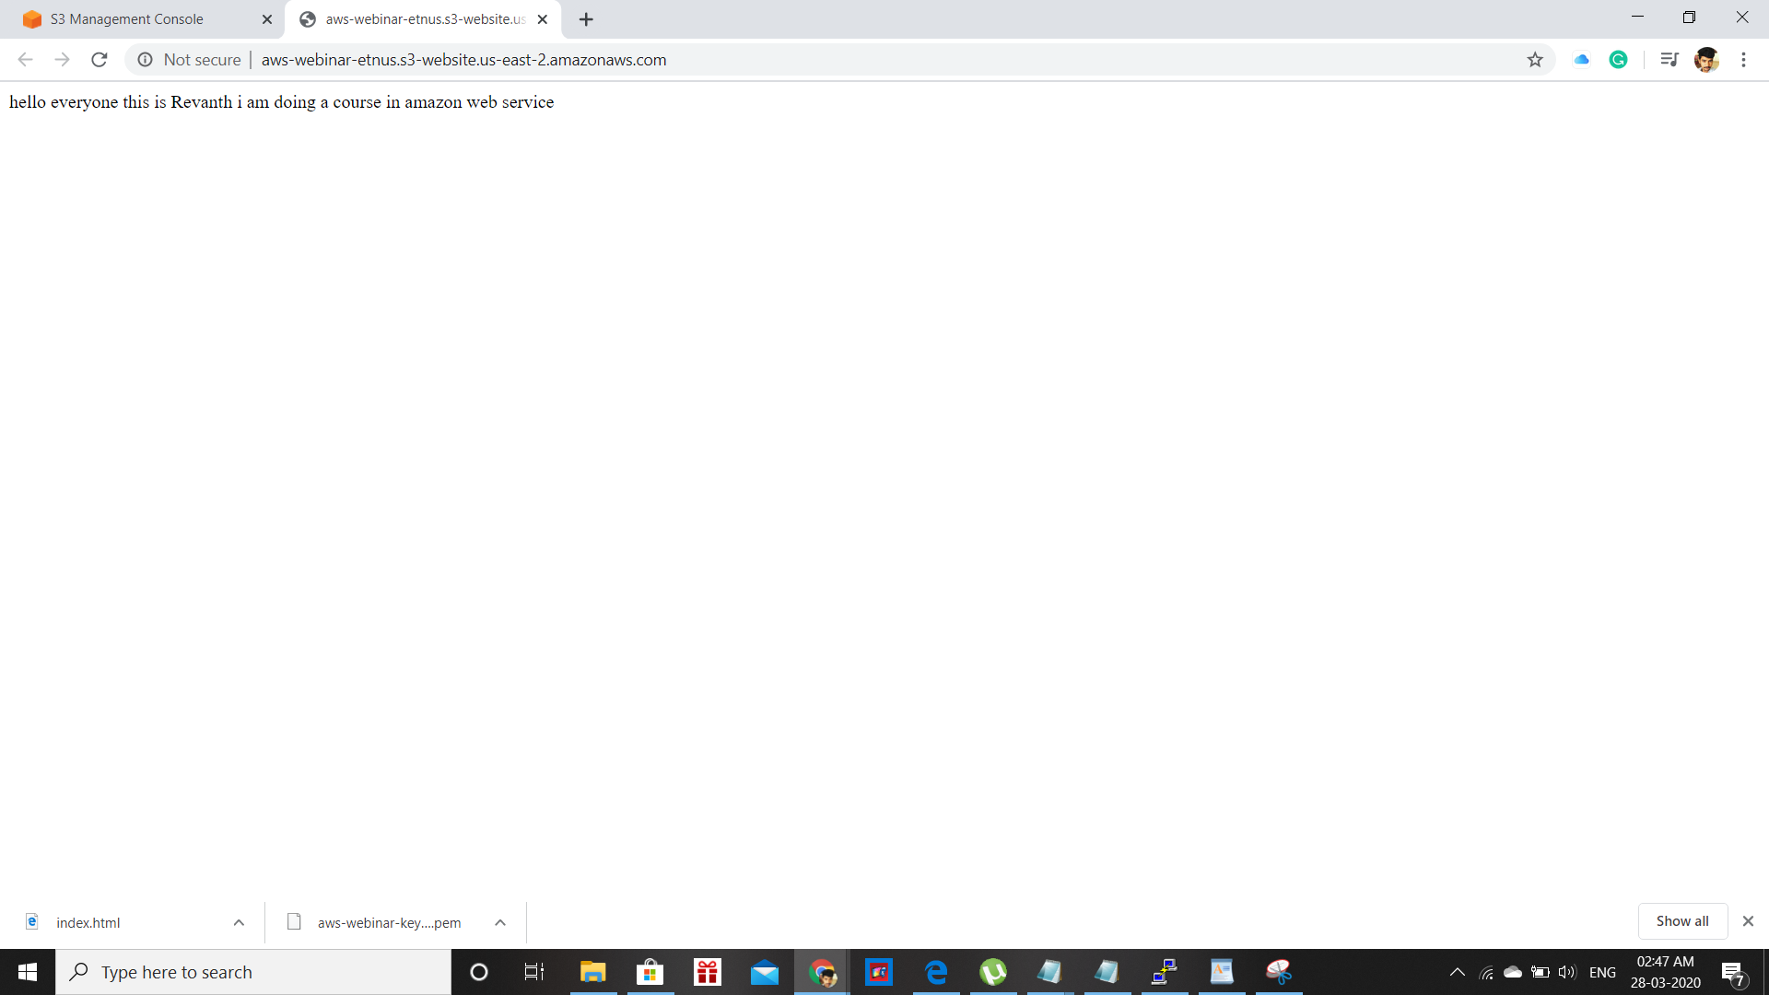

**Screenshots needed for rekognition:**

**1.Face detect:**

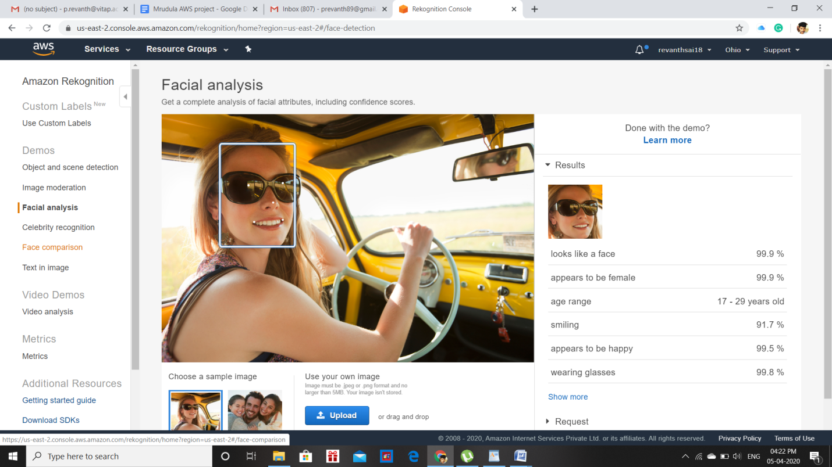

**2.Face compare:**

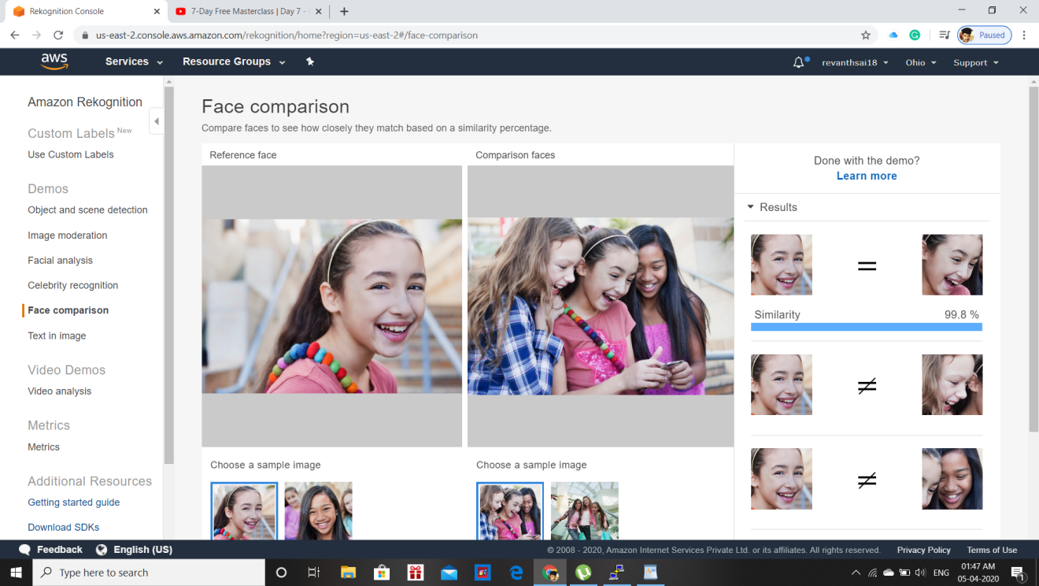

**3.Celebrity recognition**

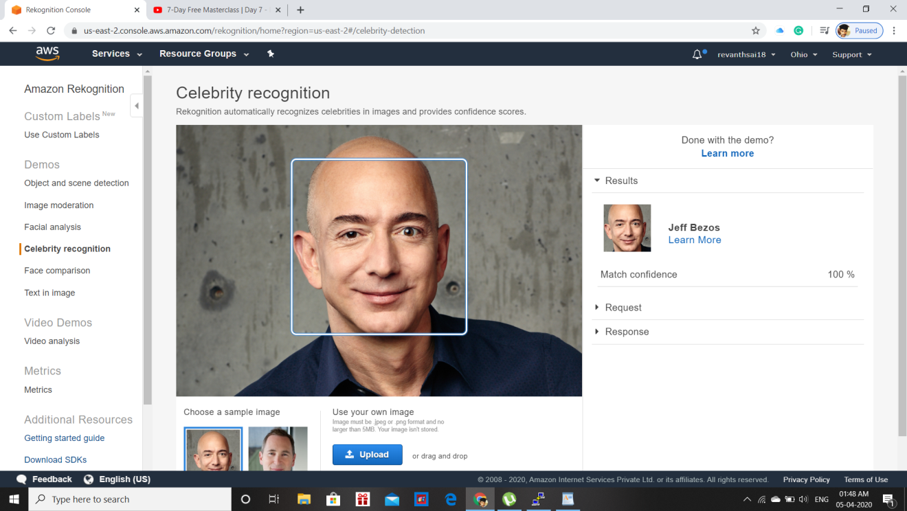

**4.Text in image:**

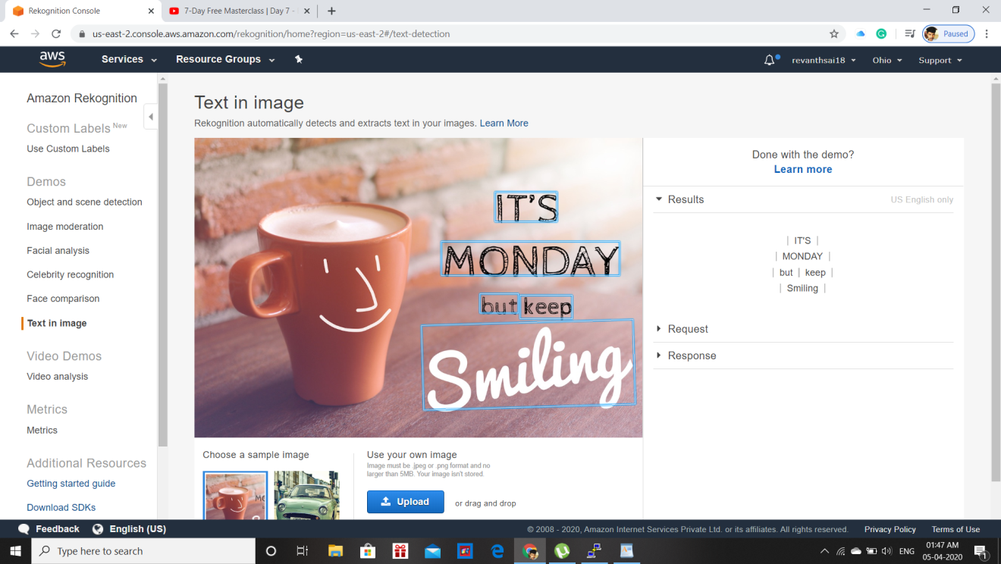

**Screenshots needed for EC2 and S3:**

**1.Installing aws-sdk:**

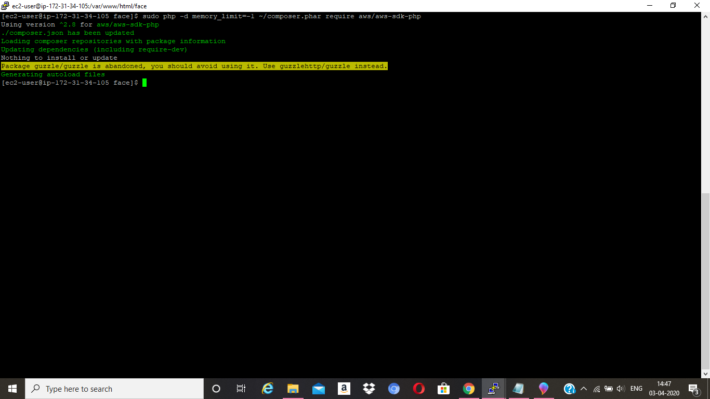

**2.Installing php:**

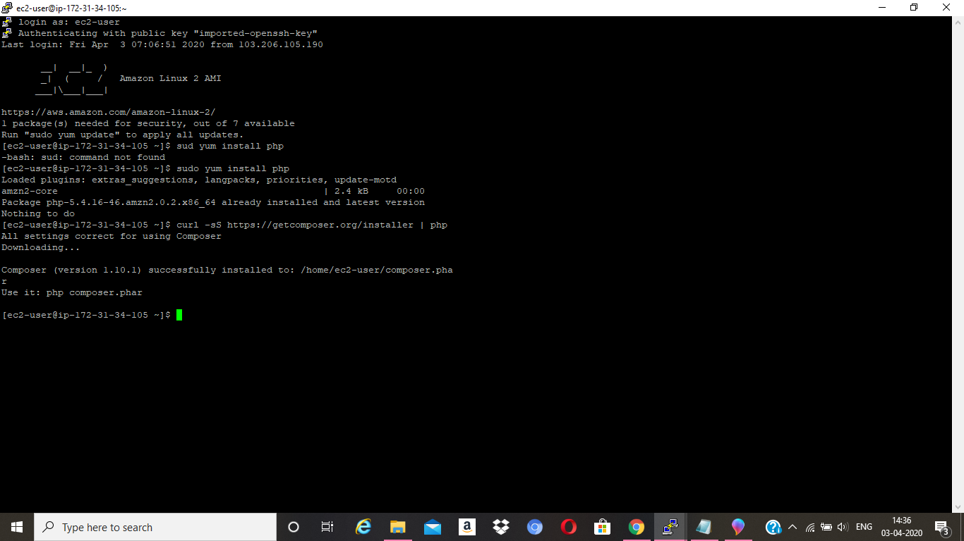

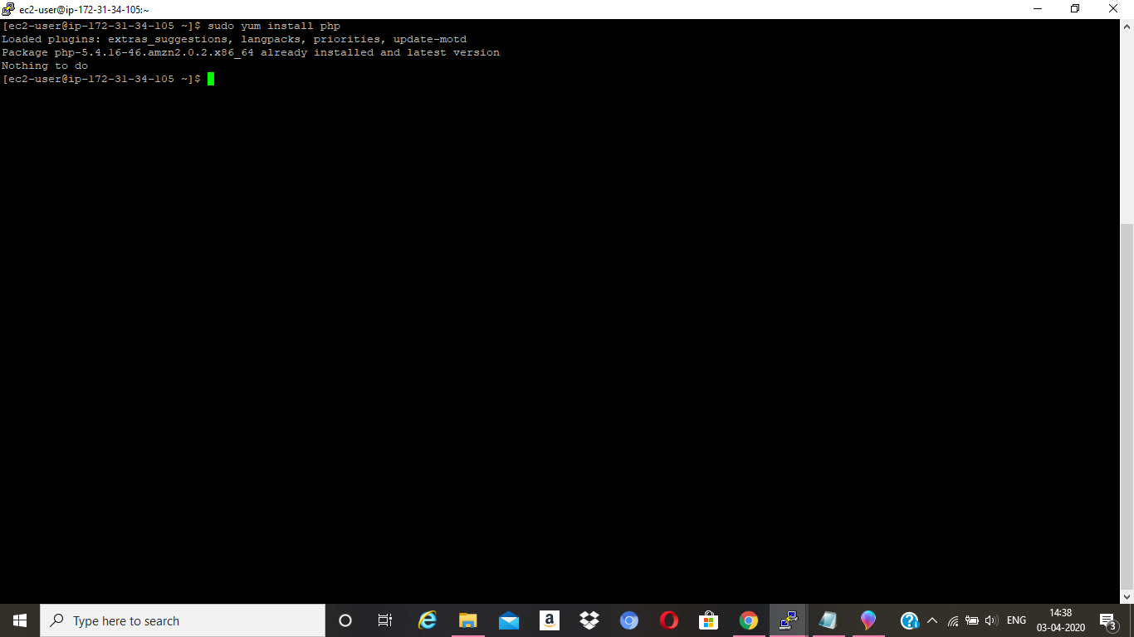

**3.Installing .php file code:**

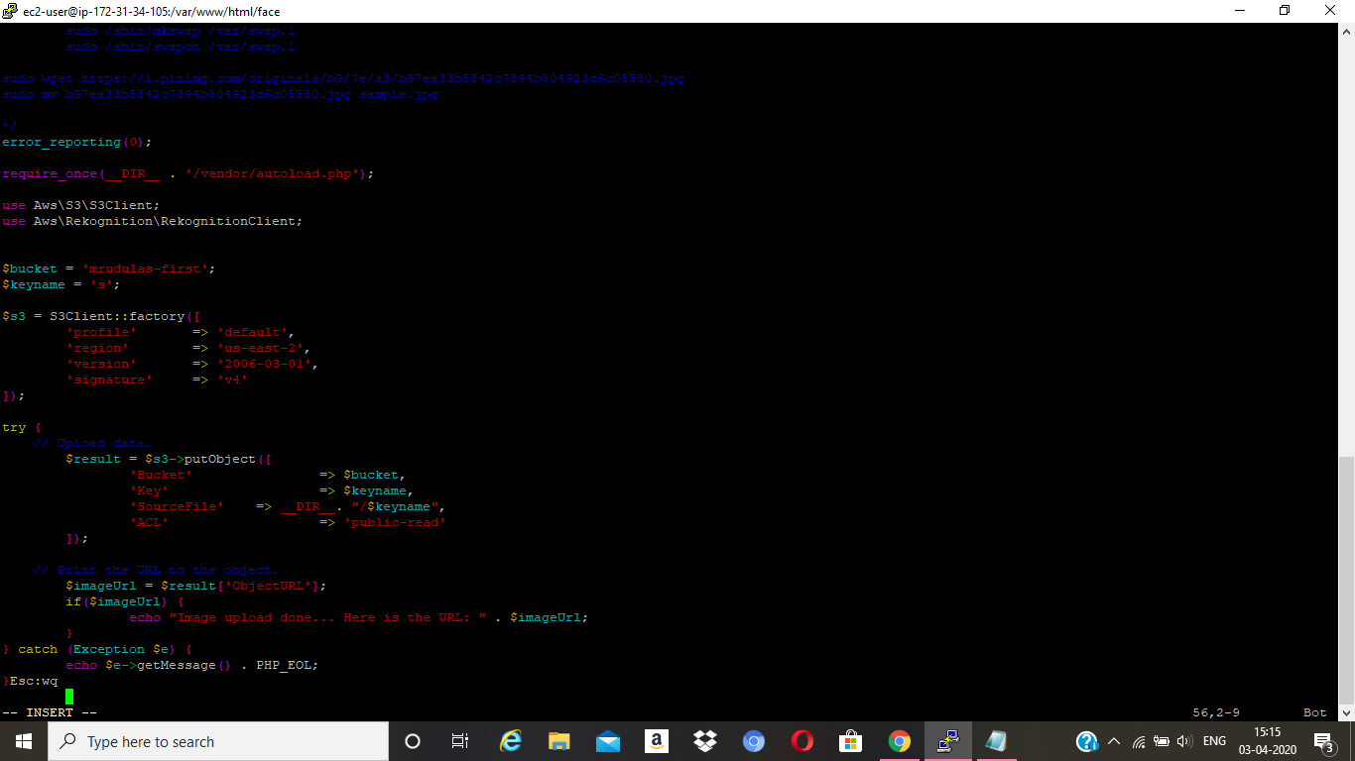

**4.Upload success screenshot:**

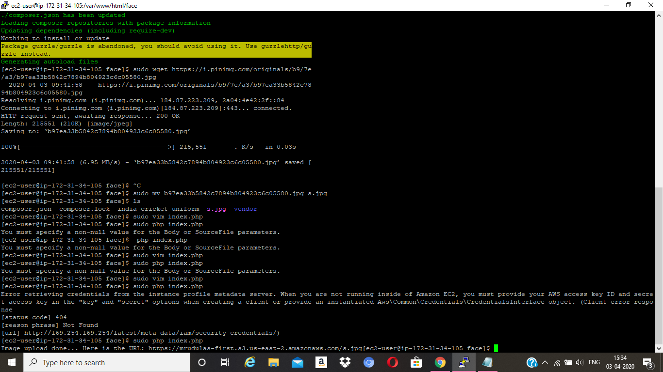

**Screenshots needed for EC2 & Rekognition:**

**1.Face detect success screenshot:**

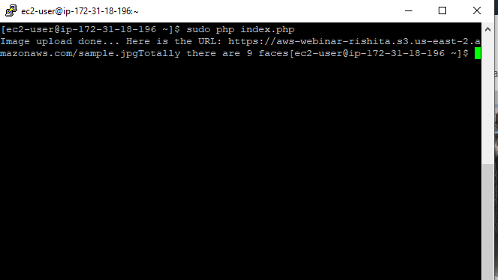

Thankyou